
U
ltrasonic Devices:
Are they just another nasty tool to punish our dogs for talking, thinking, and feeling?

Companion animals represent a multi-billion dollar industry that has attracted no shortage of greedy players who manipulate and distort truth for financial gain, giving no thought for the lives they endanger. Manufacturers frequently fail to disclose that their products are potentially dangerous.¹ Products marketed for dogs, ranging from toxic chemicals found in pet food to those infused in flea collars, to the draconian electric shock collar, have all caused immeasurable suffering.^{2,3} Pet parents have been taken advantage of for decades and are still being exploited. Agencies tasked with combating false advertising are either asleep at the wheel or lost in the past, with record players and smoking on planes.

Devoted pet parents will want to know that ultrasonic dog silencers are yet another product that may not work as advertised. Wasting our money on worthless items is one thing, but being tricked into purchasing a product marketed as safe, when it is not, is a whole other level of deception.

Lately, there has been a marketing surge for ultrasonic devices to stop dogs from barking. Some of the ads not only distort the truth; they downplay or omit altogether the harm they can inflict. They are also insulting. One company states in an ad that the reason you should choose their product is because, “The collar's design shows clear attention to the dog's comfort. Its shape mimics the contours of a dog's neck.” Thank goodness for that, as those square collars that everybody else sells are a real pain. Seriously, that comment is silly puffery. Where the real deception lies is when a company asserts that the stimuli their devices emit — be it sound, static/shock, vibration, or a combination thereof — are gentle, safe, and “strengthen the bond between dog and owner.”

******

“However Much You Deny the Truth, It Goes on Existing” - George Orwell
Science infers that through the understanding of hearing and observing the behavioural effects of sound on dogs, the effects can range from unremarkable to highly aversive; essentially, from indifference to sheer terror and attempts to escape.⁴ The outcome depends on the dog and the components of the sound: frequency, duration, volume intensity, etc. There are no minimum quality standards required for many devices, leaving pet owners completely in the dark as to how a product is functioning and what exactly their dog is enduring. If a product gains a reputation for not performing as harmlessly as advertised, the manufacturers can simply reintroduce it with new packaging, modify it in some minor way, or just rename it. Yet, it will still be the same old repugnant device it has always been.

Ultrasonic dog trainers are handheld remotes that when activated emit a high frequency sound that dogs find disturbing. They are used to stop barking and other behaviours. The ultrasonic anti-bark collar is equipped with a microphone that activates when the dog barks.

Noise reactivity is a prevalent issue in companion dogs, and it has been reported that as much as 50% of the dog population will, at some point in their lives, be mildly to severely affected by sound.^{4,5}

The stationary version of ultrasonic devices, used both indoors and outdoors, is equipped with a microphone that activates when it detects a dog barking. They can also inadvertently be activated by other surrounding sounds. If there is more than one animal in a household, all the animals will be affected. This is a significant issue often not considered by users.

Below are a few quotes from ads for various anti-bark devices, making unsupported claims that high-frequency sound waves are safe and humane for animal training:

- “A nice gentle noise that gets his attention.”

- “Works for all breeds and sizes. Whether you have a small, sensitive pup or a large, stubborn dog.”
- “Works like a magic switch, one quick push of a button and it all stops instantly…”

- “Are less harmful to pups than shock collars.”

- “It’s a sound that inspires them”

- “Humane and non-invasive”

- “Ensuring effective behavior correction in any environment”

- “Alternate different modes adapts to different dogs providing effective bark control without causing pain or distress,”

- Dog learns to control excessive barking without stress, confusion, or harm.
- “Train without yelling, punishment, or confusion”
- “Designed to reduce unwanted barking by up to 90%”
When a tool’s appearance or functionality deters a potential customer from wanting to purchase it, a persistent salesperson knows just how to overcome this by tapping into their emotions. Proponents of shock collars are old hands at emotional manipulation. They exploit a dog guardian’s love for their dog by not so subtly suggesting that things can go wrong — very wrong — without a shock collar. That improbable dangers are highly probable and that tragedy awaits. If anything should ever happen, how will you live with the guilt? Ka-ching! Another sale.

*****

Standing Next To Ugly Doesn’t Make You Pretty

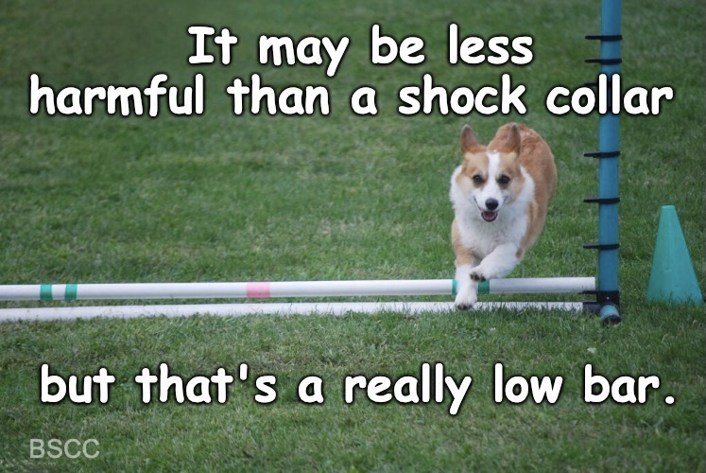
Shock collars, you say? I thought this was about ultrasonic devices. It is, but various manufacturers have chosen to compare their products to the notorious shock collar! They assert their devices offer a more humane, ethical, and superior anti-bark solution than shock collars. Could they have chosen a lower bar to compare their products with? A training tool that doesn’t emit painful electric shocks is not evidence that it is pain-free or humane. Although the potential severity of harm differs from one tool to another, harm remains harm, and punishment is still punishment.
Photo by morning magenta

If sellers of aversive tools cannot accurately explain how their device will impact an animal and ensure in good conscience that it will not do harm, then that is a problem. Here is a classic little gem, a short 3 minute and 36 second video by Jean Donaldson, author and founder of The Academy of Dog Training. It makes clear as day what not to fall for: “Magical energy communication neurobabble trainology.” All will be revealed once you watch the video.

*****

Oh, That’s Good, No, That’s Bad!

Feedback from users of ultrasonic training devices differs significantly. Some say they work, while others claim their dogs don’t respond at all and continue to bark. Still, others say their dogs are minimally affected; they stop barking temporarily but become desensitized and resume barking. The most troubling accounts come from dog guardians who report that their dogs are extremely upset, agitated, and frantic when they hear the noise. Dogs possess excellent memories, meaning a single distressing, obnoxious, noise episode can cause a dog who was previously not noise-sensitive, to become noise-sensitive.

One afternoon, for no apparent reason, a friend's smoke alarm malfunctioned and emitted an ear-piercing shrill. It was clearly not ultrasonic because it was audible to both humans and dogs. She said the noise was so piercing that even when it was silenced it continued to reverberate in her ears. Startled and frantic, it took her several minutes to disable the alarm. She quickly went in search of her Standard Poodle and found her cowering in the bedroom, the room farthest from the alarm. Her normally happy, well adjusted dog was trembling and whimpering, and continued to tremble after the alarm was silenced. She worries that this may impact her dog long term.

Fearful dogs can be triggered by even the most mundane of sounds. Equipment in and outside our homes might emit whines, hums, and noises we think are a non-issue since we can’t hear them ourselves. These and other unexpected noises in a home emphasize the importance of allowing dogs free run of their homes, not crated, so they can move to where they feel most comfortable and safe. This also highlights why doggie doors are ideal when dogs need to escape bad situations inside. Most of us go to great lengths to protect our dogs from accidental harm. Why would we ever want to deliberately cause them to suffer? Pity the hypersensitive dog who is genetically predisposed to react to even the most mundane of sounds. Include on the more sensitive list the anxious senior dog who also responds more intensely to unpleasant sounds.^{6,7} These ultrasonic anti-bark devices could strike terror into them, and the damage could be irreversible,

Below are screenshots of purchasers’ reviews. Some will accuse me of cherry-picking them. I did. I used the ones that made my points. It is also relevant to note that once I Googled ultrasonic anti-bark devices, I didn’t have to look long before finding many comments from dissatisfied customers.


One of the reviews came from an owner who subjected a 10-week old puppy to the ultrasonic sound at its maximum setting. Puppies have limited coping skills, and are developmentally sensitive. The likelihood of that pup developing health issues, including hearing loss, is considerable. I know where my sympathies lie, and they aren’t with the pup’s owner who had their sleep disturbed. It’s with the lonely little hostage calling out for his mom, the one who had no choice in being there.

It’s important to recognize that when we read reviews, ads, or testimonials, we can never be certain if they were placed by the product’s creator, were paid endorsements, are truthful, or fabricated. They could be comments left by someone harbouring a grudge or by a rival company intending to discredit its competition. Take reviews and testimonials with a grain of salt.

*****

Is it Collateral Damage When It’s Done on Purpose?

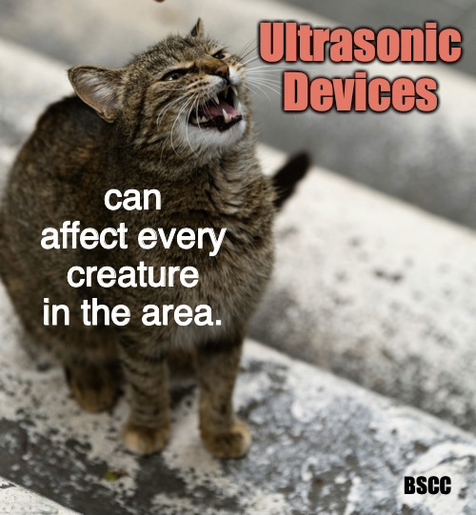
Do people understand how punishing noise can be for dogs? I suspect some do. It explains a product called the “Dog Silencer Face Plate,” which camouflages the ultrasonic outdoor model to look like a birdhouse or benign tree ornament. This makes it less identifiable to friends and neighbours, enabling the user to dodge unwanted judgment. These disguised outdoor versions are also covertly used to quiet a neighbouring dog, without the dog parent’s knowledge or permission. What people might not realize is that when an outdoor ultrasonic unit is left turned on permanently, at high settings, every dog and cat within hearing distance is affected, encouraging some to flee. Wildlife can also be disrupted ⁸ and animals may be forced to leave an area and abandon their homes. Worsening the situation even more is when the device appears not be working because a dog continues to bark, so the punishment is compounded with multiple devices, and additional aversive techniques are applied.
Photo by Leopold

In Edmonton, Alberta, Canada a woman is tormented by her neighbour, who has three ultrasonic units constantly turned on high and aimed at her three dogs, one of whom suffers from epilepsy.⁹ Her dog has experienced a glaringly high number of seizures since the devices were installed.

Nowadays, it is frowned upon to even pet a dog without the owner’s consent. So how is it okay to punish someone else’s dog without their permission? Both dogs and land are legally classified as property and are, therefore, protected from a neighbour who intentionally interferes, trespasses, or damages them. Yet the owner the dogs hasn’t been able to find help. Shouldn’t a court be able to stop such harassment? As I’m not a lawyer, my speculation is as useful as a chocolate teapot. Perhaps a lawyer out there could offer an opinion? Surely, there must be some legal and moral concerns relating to this type of usage. After all, barking is not a crime.

****

Why Won’t the Damn Dog Stop Barking?

When dogs try to tell us they are distressed through incessantly barking we often respond with the wrong kind of attention. Whether they are trying to tell us they are in pain, bored, frustrated, anxious, frightened, lonely or protesting being confined, we ignore the emotions behind their barking and simply try to silence them by shouting for them to stop, or locking them away. We’ve all been there.

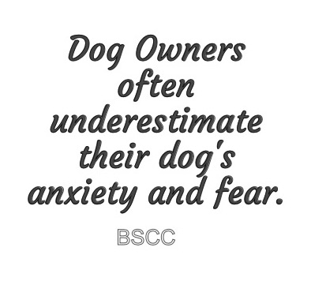
The world is deeply entrenched in relying on discipline-based quick fixes to resolve issues, so much so that frequently we do not recognize our actions as punitive. We construe punishing events as cures, education, training, therapy, and rehabilitation. This mentality is evident when people claim that dog crates ¹⁰ are a successful way to treat separation anxiety, and that shock collars rehabilitate aggressive dogs, or that spraying citronella in a dog’s face cures obsessive compulsive disorder and its problematic symptoms of compulsive licking and chewing. Heck, the next punitive device marketed could be touted as the cure for dementia! Wait, wouldn’t a crate work for that too?

*****

It Hurts When No One Listens

In the scientific literature, “Stress-Related Behaviours in Companion Dogs Exposed to Common Household Noises, and Owners' Interpretations of Their Dogs Behaviors, ¹¹, it is stated,

"Numerous signs of canine fear and anxiety were reported by survey respondents and observed in the videos, in response to both daily and irregular but normal household noises. Responses were significantly stronger to sounds characterized as high frequency intermittent than to sounds characterized as low frequency continuous. Respondents appeared to underestimate their dogs' fearfulness, and the majority of humans in the videos responded to their dogs' behaviors with amusement; welfare concerns were rarely expressed.”

Can you imagine how it would feel to try to tell someone you don’t like what is happening to you, yet they continue to make it happen, or let it happen? Dogs who go unheard, depending on their temperament, can become broken souls or learn to be hostile and aggressive. Either way, they bear the brunt of our actions and suffer needlessly.

*****

Excessive Barking Has a Reason
Turid Rugaas, founder of the Pet Dog Trainers of Europe (PTDE), made a plan at the age of three to help dogs. She excelled in fulfilling that goal brilliantly throughout her career as a dog trainer, author, and international speaker. To Turid, barking is not just noise or an annoyance; it is the language of dogs and certainly not to be punished. As she states,

"Barking is part of their language, and when a dog is barking, it means something, just like it should mean something when you speak. If a dog is barking excessively, that is because people have set them in a difficult position. There are so many simple things we can do to make excessive barking less, and make it more tolerable. Excessive barking has a reason, and cannot be punished. If you are very sensitive to barking, get a breed that barks very little, and be sure he does not develop barking because of your handling and training. It is often our own way of treating them that develops excessive barking, so do not blame the dog."

In Turid’s e-book “Barking, Understanding the Sound of Language,” she points out that dog guardians can learn to identify the various tones and pitches of their dog’s bark to gain insight into the motivations behind their barking.¹²
*****


Put It Out There And It Just May Stick
What appears benign may be sinister.
Illustration by Walter Crane, 1875

The whole point of this article is to alert pet parents that what may appear to be benign can actually be sinister.

One company, in a press release from July 2025 with the subtitle, “New 2025 Model Delivers Pain-Free Behavior Correction Using Ultrasonic Frequencies Approved by Trainers and Vets,” makes some wild and unsupportable claims. They conflate positive reinforcement training with ultrasonic training, which it most decidedly is not.

Their statement below attempts to bamboozle pet guardians. They assert:

“Recent veterinary research has demonstrated that humane training methods, particularly those employing ultrasonic technology like BarxBuddy, create measurable improvements in both canine and human health metrics. A 2025 study published in the Veterinary Behavior Journal found that dogs trained with positive reinforcement techniques showed 40% lower cortisol levels compared to those subjected to punishment-based training methods. The psychological benefits extend beyond stress reduction. Dogs experiencing consistent, humane behavioral guidance through ultrasonic training demonstrate improved neuroplasticity, enhanced problem-solving abilities, and increased capacity for learning new behaviors throughout their lives.”

I wonder how many individuals were convinced by the claims in this advertisement that the ultrasonic anti-bark device would be an effective and safe answer for their dog’s barking. The ad continued with the following assertions:
“The American Veterinary Medical Association's 2025 position paper on training aids specifically mentions ultrasonic devices as "acceptable alternatives for behavioral modification when traditional positive reinforcement methods require additional support."This endorsement has contributed to BarxBuddy's credibility among professional dog trainers and veterinary practitioners nationwide.”
You don’t say. That’s quite a claim! Unable to find the source of the above statement anywhere, including on the AVMA’s website, I was not surprised when I received clarification from Michael San Filippo, the AVMA Senior Media Relations Manager, stating:
“ The AVMA, does not have a position statement on training aids, nor do they endorse specific products.”
This ultrasonic manufacturer’s statements are unfounded. Hence, their further claim that their devices have emerged as the gold standard for safe, science-backed canine behavior management is a whole lot of nothing wrapped up in a fairy tale.
*****
You Can Wear a Halo or You Can Wear Horns (halos are lighter)
Studies find training methods matter, and training with punishment can lead to increased fear, aggression and other behaviour problems.¹³ After years of participating in pet expos and engaging with thousands of amazing pet rescuers, pet parents, trainers, veterinarians, and other dog advocates, many of them shared a common observation: the dogs they cared for that were trained with punishment all showed signs of stress, anxiety, and fear of expressing themselves. It’s no secret feelings don’t just disappear; when they are suppressed, they fester.

According to Freud:
“Unexpressed emotions will never die. They are buried alive and will come forth later in uglier ways. —Sigmund Freud

According to the American Veterinary Society of Animal Behaviour (AVSAB) they do not support the use of aversives in any context, regardless of the tools used or the trainer’s level of experience.

“The consequences and fallout from aversive training methods have been proven and are well documented. These include increased anxiety and fear-related aggression, avoidance, and learned helplessness.” - AVSAB

Their full Humane Dog Training position statement recommends
reward based training methods, based on current scientific evidence, be used for all dog training, including treatment of behavior problems.¹⁴

Our dog’s barking can be exasperating for us, even though we adore them. Can you imagine how your dog’s incessant barking is affecting your neighbours? When a neighbour complains, take them seriously for their sake and yours. Some ways to significantly alter a dog’s barking are by changing how they feel. This can be achieved by altering their routines and environments. It’s a swift and dramatic way to enhance their emotional state. A tasty breakfast, removing the door from the crate, more bathroom breaks, puzzles, or exercise/playtime outside in the fresh air, installing a doggy door, better nutrition, massages, and music, can all work wonders. Don’t leave your dog outside alone and bored all day. If they bark to come inside, bring them in. It is one of the simplest ways to give your neighbour relief.

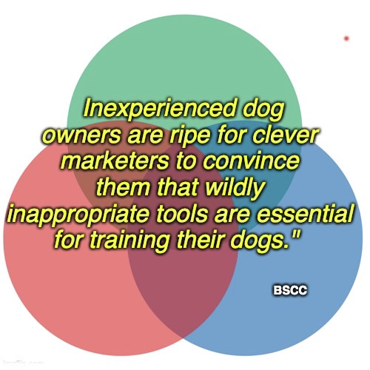
It is impossible to predict how ultrasonic sounds will make any dog feel, which is precisely why they should not be used. Without physical evidence of the harm they cause, a dog’s pain is inconspicuous. People who live with animals, and especially those who are new to having dogs in their lives, often feel lost trying to find humane guidance to help them and their dogs thrive. Dogs bark: they need to bark.¹⁵ A straightforward yet powerful question to ask yourself before relying on any overhyped wonder tool is, “If I wouldn’t want it used on myself or my child, then why would I consider using it on my dog, the most defenceless member of my household?” This should bring instant clarity. You have all the power; they have none. Your choices determine the quality of your dog’s life.

The sounds that bring dogs the most joy are the gentle, soft, happy, voices of those they love most; it’s music to their ears. Oh yeah, and the crinkling of the potato chip bag. That ranks up there too.

Below are a few videos featuring reward based dog trainers sharing care advice and explaining why dogs bark, as well as how to compassionately modify their barking behaviour. I hope you find them intriguing and that the approach / style of at least one of the trainers resonates with you. Any one of these positive trainers will be more beneficial than any gadget you could ever purchase.

Gwendy Williams

‘Advocating for the exclusive use of pain-free training methods'

Stop Barking Tips

How to Teach Any Dog To Stop Barking Humanely - Zak George
https://www.youtube.com/watch?v=Dza9vO3UZkQ

Stop Barking Playlist-Kikopup
https://www.youtube.com/playlist?list=PLE345355EA335F575

DOGTV - Victoria Stilwell 354 seconds on Barking
https://www.youtube.com/watch?v=Sm4zoJykjYY

How to Teach Your Dog Not to Bark - The Battersea Way
https://youtu.be/vaBNrorLFpw?si=yIgAzOkvydlntmta

Barking and lunging at scooters. How Diesal’s Behaviour Has Changed -Zurison
https://www.dogcharming.com.au/diesels-behaviour-change-video.html

Do No Harm Dog Training and Behavior Manual P. 241-244, Linda Michaels M.A. Psychology, 2022
https://www.donoharmdogtraining.com/

Barking, Barking, Barking, Linda Michaels, Positively, 2011
https://positively.com/dog-training/post/behavior-problems-barking-barking-barking

Barking Up the Right Tree - Dr. Ian Dunbar, 2021
Barking Up the Right Tree

Resources

1. $1.9M PetSafe Electronic Collar Class Action Settlement, Top Class Action, October 2025
https://topclassactions.com/lawsuit-settlements/open-lawsuit-settlements/1-9m-petsafe-electronic-collar-class-action-settlement/

2. A Pesticide-Laced Flea Collar Has Been Linked to Almost 1,700 Pet Deaths. Why Hasn’t the EPA Issued a Warning?, IN Times, Johnathan Hettinger March 2021
https://inthesetimes.com/article/flea-collar-pet-death-epa-pesticide-regulation

3. Top 10 Dog Food Ingredients to Avoid & Why, Christine Franklyn, The National Canine Cancer Foundation, Jan 2021
https://wearethecure.org/top-10-dog-food-ingredients-to-avoid-why/

4.Aversive responses of dogs to ultrasonic, sonic and flashing light units, J.K. Blackshaw, G.E. Cook, P. Harding, C. Day, W. Bates, J. Rose, D. Bramham, Applied Animal Behaviour Science, Volume 25, 1990
https://www.sciencedirect.com/science/article/abs/pii/016815919090064K

5. Phenotypic determination of noise reactivity in 3 breeds of working dogs: A cautionary tale of age, breed, behavioral assessment, and genetics, Karen L. Overall, Arthur E. Dunham, Soraya V. Juarbe-Diaz, Journal of Veterinary Behaviour, 2016
https://www.sciencedirect.com/science/article/abs/pii/S1558787816301526

6. Sound sensitivity in dogs: protecting emotional welfare and the human–pet bond, Claire Hargrave, Companion Animal, July 2022
https://www.ukvetcompanionanimal.com/content/clinical/sound-sensitivity-in-dogs-protecting-emotional-welfare-and-the-human-pet-bond/

7. Turn the volume down: Noise hypersensitivity in dogs, Joy T.Y. Chin, Samantha X.L. Poh, Eduardo J. Fernandez, Susan J. Hazel, Journal of Veterinary Behavior,
Volume 79, June 2025
https://www.sciencedirect.com/science/article/pii/S1558787825000413

8. Scientific studies show that birds are affected by ultrasound, Dr. Philip Whitford,
Bird -X
https://www.bird-x.com/filebin/pdf/research/Ultrasound_Whitford-Study_observations.pdf?fbclid=IwY2xjawOMawVleHRuA2FlbQIxMABicmlkETFZaks2U2FORGxScjRYZE9Tc3J0YwZhcHBfaWQQMjIyMDM5MTc4ODIwMDg5MgABHk70txfg1qX6njliJfe_AwbW0B2HZJFSbxeB5aR7V5FMA06kg0l7pFZRGcSw_aem_XiXlqjgXWKu9u0J_5dgFKQ

9. Ultrasonic Devices Harmful to Dogs, by Kelly, Dog Health Guide, 2023
https://www.dog-health-guide.org/are-ultrasonic-devices-harmful-to-dogs.html

10. Dog Crates: If They Sound Cruel, It’s Because They Are, Gwendy Williams, Barks, Pet Professional Guild, 2024
https://www.petprofessionalguild.com/barks/barks-magazine-blog/escape-proof-crates-if-they-sound-cruel-its-because-they-are/

11. Stress-Related Behaviors in Companion Dogs Exposed to Common Household Noises, and Owners' Interpretations of Their Dogs' Behaviors. Grigg EK, Chou J, Parker E, Gatesy-Davis A, Clarkson ST, Hart LA., Front Vet Sci., November 2021
https://pmc.ncbi.nlm.nih.gov/articles/PMC8606548/

12. Calming Signals - the Art of Survival, Turid Rugaas, 2013
http://en.turid-rugaas.no/calming-signals---the-art-of-survival.html

13. The relationship between training methods and the occurrence of behavior problems, as reported by owners, in a population of domestic dogs, Emily J. Blackwell, Caroline Twells, Anne Seawright, Rachel A. Casey, Department of Clinical Veterinary Science, University of Bristol, United Kingdom, September 2008.
https://www.sciencedirect.com/science/article/abs/pii/S1558787807002766

14. Position statement on Humane Dog Training, American Veterinary Society of Animal Behavior
https://avsab.org/wp-content/uploads/2024/12/AVSAB-Humane-Dog-Training-Position-Statement-2021.pdf

15. Are Ultrasonic Dog Training Devices Really Safe and Humane? Jessica Pierce, Ph.D., Psychology Today, 2020
https://www.psychologytoday.com/ca/blog/all-dogs-go-heaven/202001/are-ultrasonic-dog-training-devices-really-safe-and-humane

Additional Resources

Most Dogs Show Anxiety-Related Behaviors, Study Finds, Katherine J. Wu, Smithsonian magazine, March 2020
https://www.smithsonianmag.com/smart-news/three-quarters-dogs-show-anxiety-related-behaviors-study-finds-180974361/

Prevalence, comorbidity, and breed differences in canine anxiety in 13,700 Finnish pet dogs, Milla Salonen, Sini Sulkama, Salla Mikkola, Jenni Puurunen, et al, Scientific Reports, 2020
https://www.nature.com/articles/s41598-020-59837-z

Fear, Phobias, and Anxiety in Cats and Dogs, VCA - By Ellen Lindell, VMD, DACVB; Kenneth Martin, DVM, Diplomate, ACVB; Debra Horwitz, DVM, DACVB & Gary Landsberg, DVM, DACVB, DECAWBM
https://vcahospitals.com/know-your-pet/fears-phobias-and-anxiety

Punishment in Animal Training, Susan Nilson and Niki Tudge, Barks Blog, Pet Professional Guild, June 3, 2022
https://www.petprofessionalguild.com/barks/barks-magazine-blog/punishment-in-animal-training/

Royal Palm Beach woman charged with animal cruelty after allegedly placing several ultrasonic dog repellents, Sooji Nam, WPBF News, March 2024
https://www.wpbf.com/article/florida-royal-palm-beach-animal-cruelty-ultrasonic-insect-and-dog-repellants/60130006#:~:text=One%20woman%20in%20Royal%20Palm,making%20you%20run%20back%20inside?

